Cisco Intersight Server Operating System Installation
Introduction
Cisco Intersight introduces the ability to install vMedia-based operating systems on the managed servers in your data center. With this capability, you can perform an unattended operating system installation on one or more Cisco Unified Computing System (Cisco UCS) C-Series standalone servers and Cisco Intersight Managed Mode (IMM) servers (C-Series, B-Series, and X-Series) from your centralized data center through a simple process.

Cisco Intersight Operating System Installation
This topic describes how to install an operating system by using Cisco Intersight. It also describes three options that you can use to install an operating system.
Introduction to Operating System Installation Workflow
As the name of the server action implies, the Install operating system action installs an operating system on the target server. This capability is different than traditional tools from operating system vendors or utility software providers that lack an underlying knowledge of the specific hardware target. Cisco Intersight operating system installation streamlines the integration of vendor-specific drivers and tools into the operating system installation process.
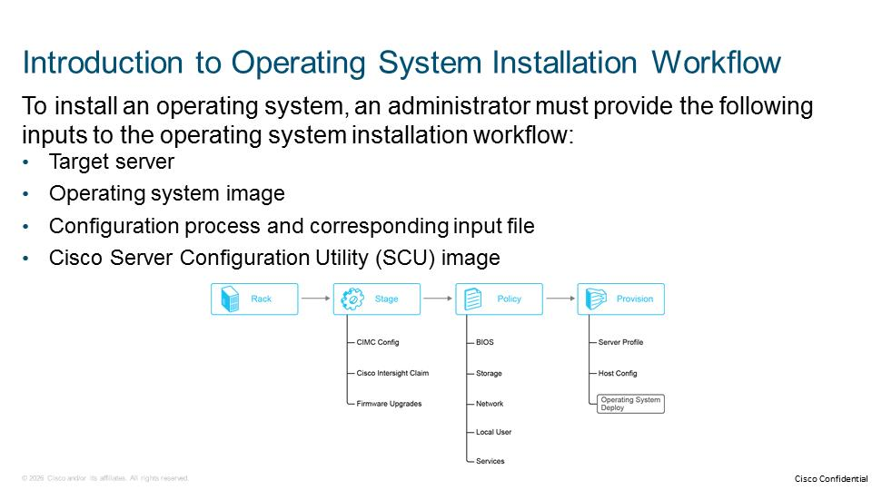
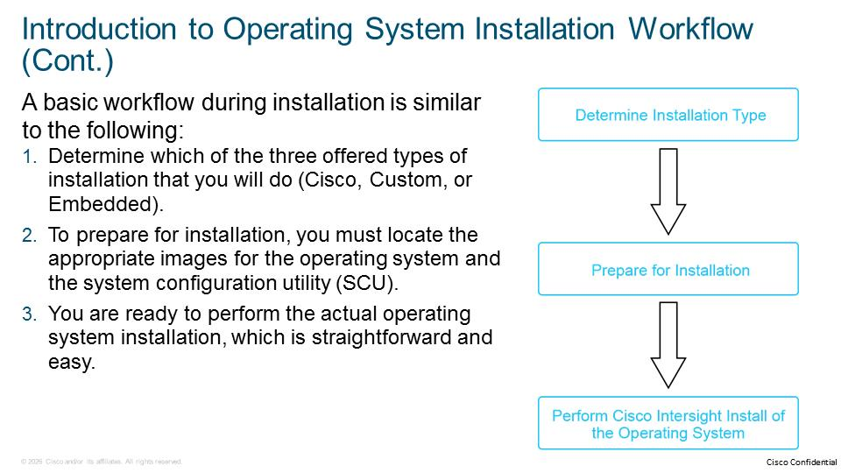
Operating System Installation Types
Cisco Intersight currently supports an unattended operating system installation that is enabled by one of the following configuration sources:
- Cisco: Use a Cisco-validated template to install the selected operating system version. Cisco Intersight lets you view the Cisco-provided configuration files based on the operating system image version that you select. You can see the content of the configuration files and the required and optional parameters for the selected operating system installation. The Cisco option is ideal for typical operating systems installations, but Cisco expands the list of supported operating systems continuously. Using the Cisco-validated template is simple because you are required to assign basic mandatory parameters such as IP settings, the hostname, and the password. You must modify the configuration file if you want to provide additional settings.
- Custom: The administrator provides a configuration file containing an installation script or configuration (kickstart) file with the necessary placeholders for the parameters. A placeholder is a variable for a configurable entity. Cisco Intersight assigns the value that the administrator enters in the placeholders to the appropriate parameters.
- Embedded: The configuration (kickstart) file is embedded in the operating system ISO image. The ISO image contains the necessary references to the kickstart file from the bootloader configuration to execute an unattended operating system installation. This option is suitable for an operating system image that includes a configuration file.

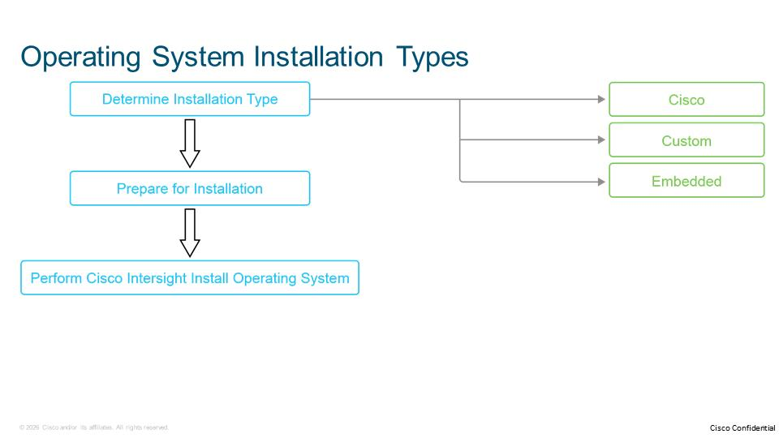
You will initiate the operating system installation wizard for any method by navigating to the target server on which you want to install the operating system. From the Action menu, choose Install Operating System.
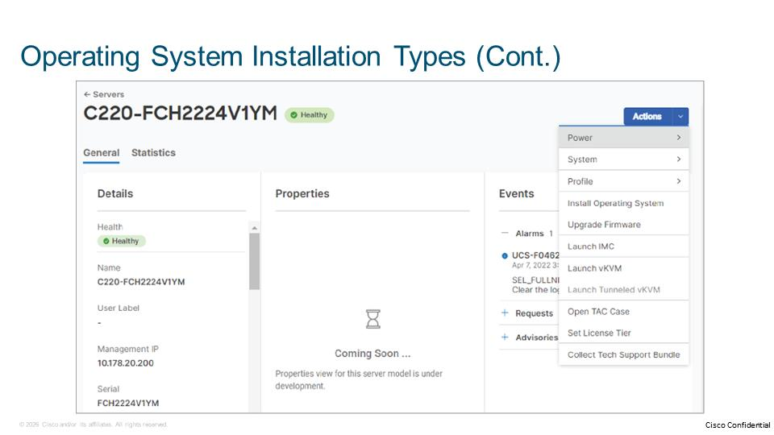
Operating System Installation Types Use Cases
Each of these operating system installation type options has its use cases.
- The Cisco option is the easiest method. Cisco has tested and validated the methods for each supported operating system to match best practices. The default installation workflow fits a typical installation, but if it does not exactly match your needs, you can modify the configuration. The configuration file supports scripting and complexity for almost any situation.
- The Custom option allows you to use your configuration file. Before people began using Cisco Intersight, they often had custom configuration files. The Custom option allows you to use your custom configuration files. Users can also place variables in the configuration file so that the Cisco Intersight GUI will ask for the values of those variables (such as hostname and password).
- In the Embedded option, you can use any ISO image that has a configuration file inside. From the Cisco Intersight perspective, the Embedded option is a server-side installation where Cisco Intersight only provides an ISO image to the server. Then the server boots and installs the ISO image by using the settings that are provided within the ISO image.
- The Embedded method can run any utility for booting the ISO image, but you must build a complete ISO image with an embedded configuration (kickstart) file.

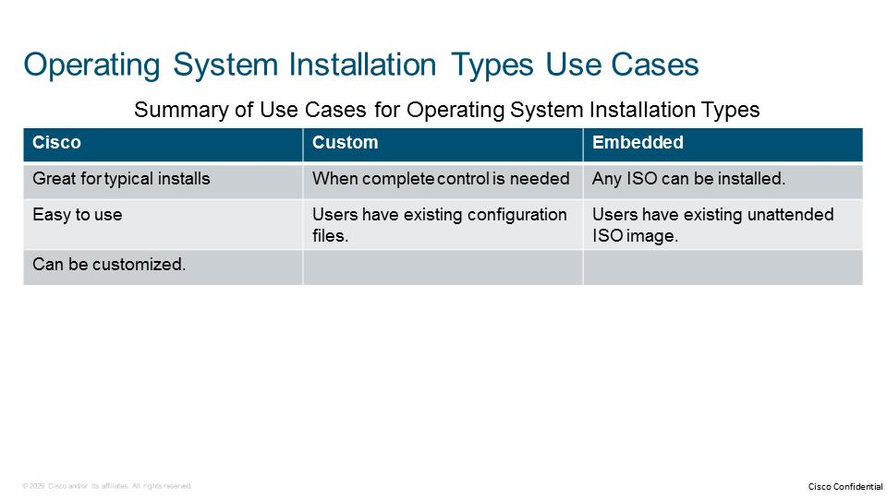
1. Which of the following types of servers can be a target for an operating system installation from Cisco Intersight? (Choose three.)
A. Cisco UCS B-Series in IMM mode
B. Cisco UCS C-Series in IMM mode
C. Cisco UCS HX-Series in standalone mode
D. Cisco UCS S-Series in IMM mode
E. Cisco UCS X-Series in IMM mode
F. Third-party server

Cisco Intersight Operating System Installation Requirements
This topic lists currently supported hardware for operating system installation features, information about supported target operating systems, and caveats to consider.
Supported Hardware
To use the operating system installation feature from Cisco Intersight, the type of target server on which an operating system is to be installed must be supported. Each management mode has specific supported servers for the operating system install feature.
Supported Hardware for the Operating System Install Feature
Standalone Mode | Servers in Cisco IMM Mode
C-Series Servers (M7): UCSC-C220-M7, UCSC-240-M7  C-Series Servers (M6): UCSC-C220-M6, UCSC-240-M6, UCSC-C245-M6, UCSC-C225-M6  C-Series Servers (M5): UCSC-C220-M5, UCSC-240-M5, UCSC-C480-M5 | B-Series (M5): UCSB-B200-M5, UCSB-B480-M5  B-Series Servers (M6): UCSB-B200-M6  C-Series Servers (M5): UCSC-C220-M5, UCSC-240-M5, UCSC-C480-M5  C-Series Servers (M6): UCSC-C220-M6, UCSC-240-M6, UCSC-C245-M6, UCSC-C225-M6  C-Series Servers (M7): UCSC-C220-M7, UCSC-240-M7  X-Series Servers (M6): UCSX-210C-M6  X-Series Servers (M7): UCSX-210C-M7

The requirements for the minimum software version for Cisco IMC, SCU, BIOS, and the device connector may be different for the same type of server in other management modes.

Supported Operating Systems
Cisco Intersight supports installation of the following versions of VMware vSphere ESXi, Red Hat Enterprise Linux (RHEL), CentOS, Windows Server, Hyper-V Server, SUSE Linux Enterprise, Citrix Hypervisor, and Ubuntu Server editions with and without the SCU. The Cisco Intersight operating system installation service supports installing an operating system on one or more managed servers.
The following tables show support information for target operating systems in each of the two management modes.
Supported Operating Systems for Installation from Cisco Intersight in Standalone Management Mode
Operating System | Cisco Template | Custom Template | Embedded (with SCU) | Embedded (without SCU)
VMware vSphere ESXi | Yes | Yes | Yes | Yes
Windows | Yes | Yes | Yes | Yes
Hyper-V | Yes | Yes | Yes | Yes
RHEL | Yes | Yes | Yes | Yes
CentOS | Yes | Yes | Yes | Yes
Ubuntu Server | Yes | Yes | Yes | Yes
SUSE Enterprise Linux | Yes | Yes | No | Yes

Supported Operating Systems for Installation from Cisco Intersight in Cisco IMM Management Mode
Operating System | Cisco Template | Custom Template | Embedded (with SCU) | Embedded (without SCU)
VMware vSphere ESXi | Yes | Yes | Yes | Yes
Windows | Yes | Yes | Yes | Yes
RHEL | Yes | Yes | Yes | Yes
CentOS | Yes | Yes | Yes | Yes
Ubuntu Server | Yes | Yes | Yes | Yes
SUSE Enterprise Linux | Yes | Yes | No | Yes

The requirements for the minimum software version for Cisco IMC, SCU, BIOS, and the device connector may be different for the same type of server in other management modes.

Limitations and Caveats
You must have an account administrator or server administrator role to use the Install OS from Cisco Intersight feature. In a read-only role, you can view one or more installed operating systems on the server.
Depending on the target operating system, additional limitations apply:
- A product key is mandatory for Windows installations.
- An answer file that is used in the Windows installations must not include the disk configuration section.
- The network device is mandatory for SUSE Linux Enterprise Server (SLES) installations.
- The Cisco template for a Windows operating system installation automatically configures the network interface LAN on Motherboard (LOM) Port 1. To use a different network interface, make the necessary changes to the network port in the answer file using a custom template installation.
- You can only configure IPv4 addresses for Hyper-V hosts or servers.
- Tracking the operating system install process for VMware vSphere ESXi requires the operating system image to include the ucs-tools vib, which is included in the Cisco Custom VMware vSphere ESXi images.

The following limitations apply to Cisco IMM servers:
- Cisco IMM servers must be associated with a server profile with a Cisco Integrated Management Controller (IMC) and LAN policy. You can configure additional policies.
- RHEL installations with Unified Extensible Firmware Interface (UEFI) Secure Boot are not supported on Cisco IMM servers.
- Cisco IMM servers do not support hosting images on an HTTP share. Cisco IMM servers only support Network File Systems (NFS), Common Internet File Systems (CIFS), or HTTPS shares.

The following limitations apply to target devices:
- Targets with the Internet Small Computer Systems Interface (iSCSI) and Non-Volatile Memory Express (NVMe) types are not supported.
- The legacy boot mode installation does not support partitions greater than 2 TIB. UEFI boot mode can be used for partitions greater than 2 TIB.

1. For which operating system Intersight installation is supported on servers in standalone mode, but not on servers in Cisco IMM mode?
A. CentOS
B. Hyper-V
C. RHEL
D. Ubuntu Server
E. Windows

Adding an Operating System Image
This topic describes how to add the operating system image to the Cisco Intersight software repository. It also provides configuration details for adding an image depending on the protocol that you choose for the share location.
Repository Locations
An administrator must add the operating system image before the installation. Before you install an operating system, you must add the operating system image source, the details of the file share location, and the protocol (CIFS/NFS/HTTP/HTTPS) to the software repository.
Cisco Intersight uses the sharing repository as the source location for the operating system image, configuration file, and SCU. When you define a repository location, you must add the parameters if any custom settings are available for the selected source. After you add the operating system files once, you can reuse them many times. As you add more and different operating system images, configuration files, or SCUs, you will see them in the list during the operating system installation process, and you can easily choose the one that you want to install.
Your files must be accessible by Cisco Intelligent Contact Management (ICM) on your target server where you want to install your operating system.
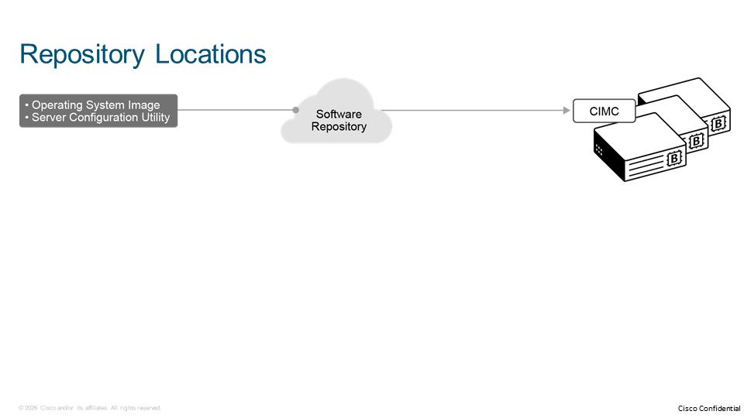
After you add the operating system image once, you can reuse it many times. As you add operating system images, they appear in the list during the operating system install process. You can easily select the operating system that you want to install.
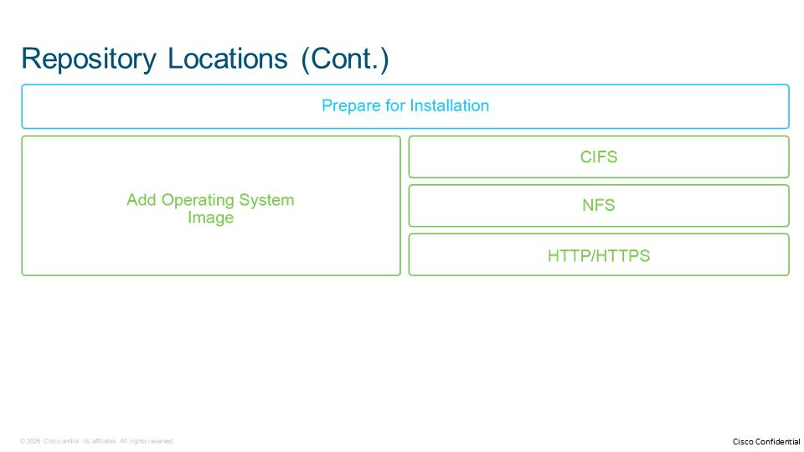
Adding an Operating System Image
From the navigation menu, click on System. Click on Software Repository, and click on OS Image Links tab. Click on the Add OS Image Link button to start the wizard for adding operating system image.
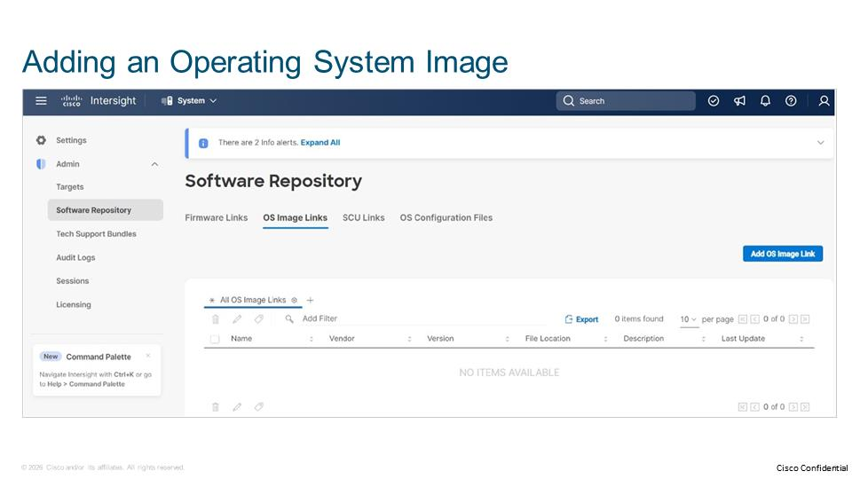
In the General section of the wizard, enter the following details about the operating system image:
- Organization: From the drop-down menu, select the organization to make a resource available to users. The organization can be a default or a specific entity, but it must be the same as the organization from which the operating system installation is triggered.
- In the transfer protocol section, select the transfer protocol configured on the repository location. Depending on your chosen protocol, you will have to populate different options. The table below summarizes the configuration options for each transfer protocol.

NFS | CIFS | HTTP(S)
File Location: The location of the image file. For example, 10.1.17.250/repo/XYZ.iso | File Location: The location of the image file. For example, 10.1.17.250/repo/XYZ.iso | File Location: The location of the image file. For example, https:// 10.1.17.250/repo/XYZ.iso
Mount Options: The choices for mounting as configured in the NFS server. Endpoints use the mount option to mount the remote share as part of a firmware upgrade or operating system install operation. | Mount Options: The choices for mounting as configured in the CIFS server. Endpoints use the mount option to mount the remote share as part of a firmware upgrade or operating system install operation. | Username/password: The strings that are the username and password respectively as configured on the HTTP(S) server.
 | Username/password: Strings that are the username and password, respectively, as configured on the CIFS server.

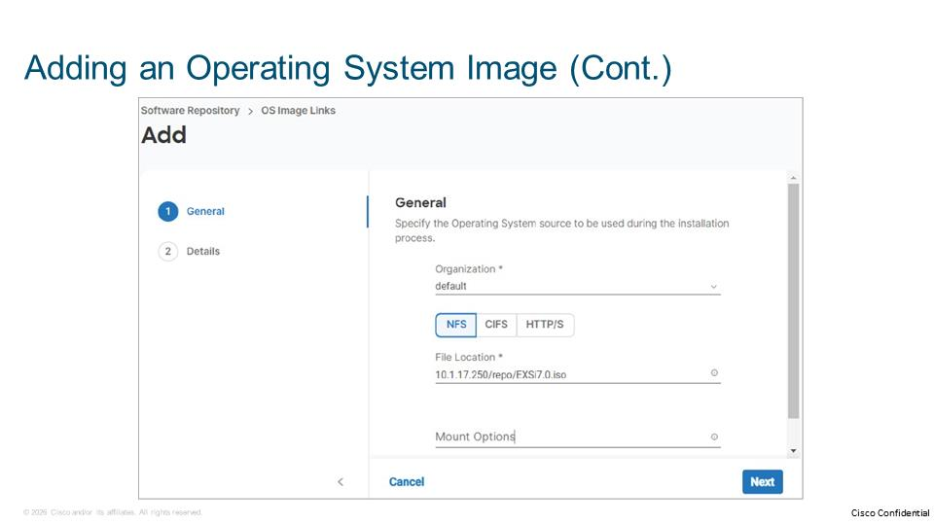
HTTP protocol is not supported for Cisco IMM servers.

In the Details section of the wizard, enter the following details about the operating system image, and click on Add:
- Name: The string is the name of the operating system file. The name is populated as part of the image import when you install the specific operating system.
- Vendor: Select the operating system vendor from the drop-down list.
- Version: Select the operating system version from the drop-down list.
The drop-down list does not include a selection for Hyper-V Server. For the Hyper-V Server 2019, select the Windows Server 2019, For the Hyper-V Server 2016, choose the Windows Server 2016.

- Description: Add an optional description of the operating system file. If the image is obtained from the Cisco inventory, Cisco provides the description.
- Add Tag: Add an optional tag to identify and search for the image.

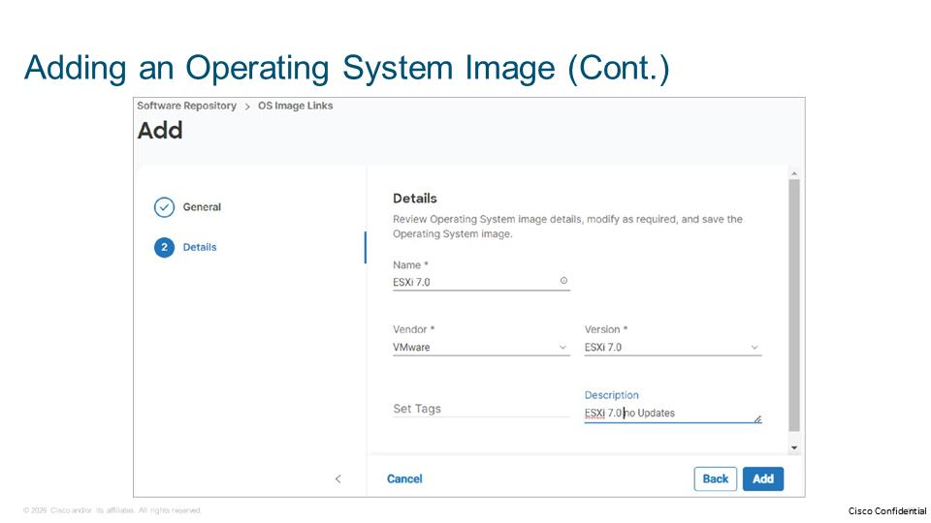
After you add the operating system to the software repository, view the added operating system in the table view. Edit or delete details of the operating system in the table view.
1. Which one of the transfer protocols have configuration options for file location, mount option, and authentication?
A. NFS
B. CIFS
C. HTTP
D. HTTPS

Adding an SCU
This topic describes how to add a Server Configuration Utility (SCU) to the Cisco Intersight software repository. It also provides configuration details for adding an SCU file depending on the protocol that you choose for the sharing location.
An SCU is an optional application that enables automated unattended operating system installation and an SCU is often required to complete the installation. An SCU helps in performing various tasks on the server, such as upgrading, troubleshooting, viewing the server health and logs, configuring the server, configuring Redundant Array of Independent Disks (RAID) volumes, and, most importantly, installing an operating system.
The Cisco UCS SCU guides you through a set of questions to help you configure the server through automatic recognition of the server hardware, with few reboots and an automated unattended operating system installation.
Procedure to Add an SCU
From the navigation menu, click on System. Click on Software Repository, and click on SCU Links tab. Click on the Add SCU Link button to start the wizard for adding operating system image.
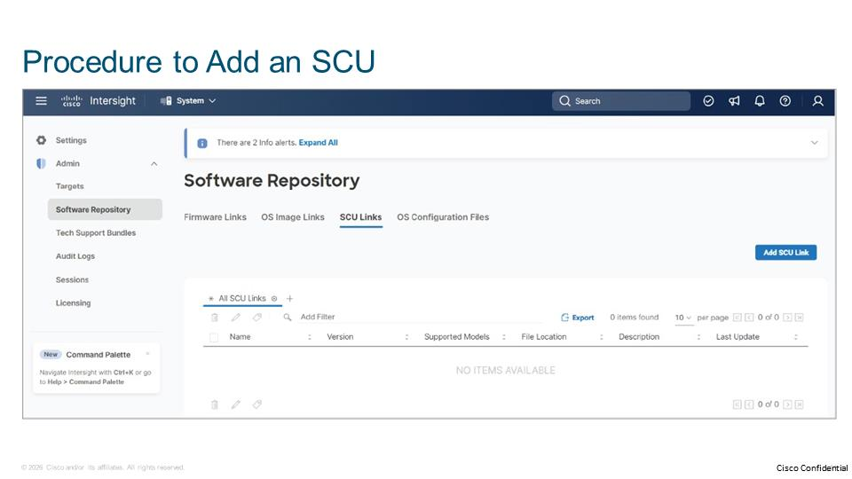
In the General section of the wizard, enter the following details about the SCU image:
- Organization: From the drop-down menu, select the organization to make a resource available to users. The organization can be a default or a specific entity, but it must be the same as the organization from which the operating system installation is triggered.
- In the transfer protocol section, select the transfer protocol configured on the repository location. Depending on your chosen protocol, you will populate different options. The table below summarizes the configuration options for each transfer protocol.

NFS | CIFS | HTTP(S)
File Location: The location of the image file, for example 10.1.17.250/repo/XYZ.iso | File Location: The location of the image file. For example, 10.1.17.250/repo/XYZ.iso | File Location: The location of the image file. For example, https:// 10.1.17.250/repo/XYZ.iso
Mount Options: The choices for mounting as configured in the NFS server. Endpoints use the mount option to mount the remote share as part of a firmware upgrade or operating system install operation. | Mount Options: The choices for mounting as configured in the NFS server. Endpoints use the mount option to mount the remote share as part of a firmware upgrade or operating system install operation. | Username/password: The strings that are the username and password respectively as configured on the HTTP(S) server.
 | Username/password: The strings that are the username and password respectively as configured on the CIFS server.

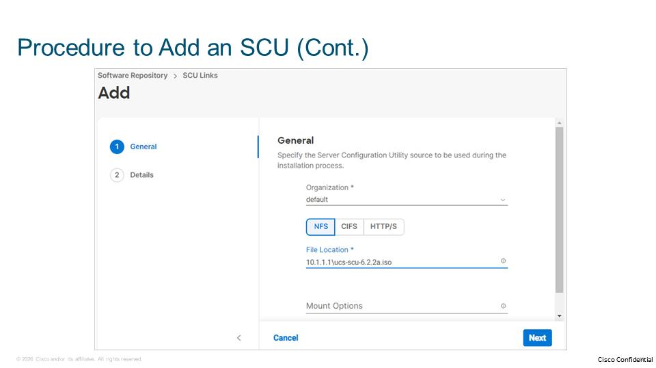
HTTP protocol is not supported for Cisco IMM servers.

In the Details section of the wizard, enter the following details about the operating system image, and click on Add:
- Name: The string is the name of the Server Configuration file. When you install an operating system, the name string is populated as part of the image import.
- Version: The vendor-provided version of the utility.
- Supported Models: The server model for which the image of the SCU is applicable. You can add up to four models.
SCU support is available for both Cisco UCS B-Series and C-Series servers.

- Description: Add an optional description of the operating system file. Cisco provides the description if the image is obtained from the Cisco inventory.
- Set Tag: Add an optional tag to identify and search for the SCU.
- In the transfer protocol section, select the transfer protocol configured on the repository location. Depending on your chosen protocol, you will populate different options. The table below summarizes the configuration options for each transfer protocol.

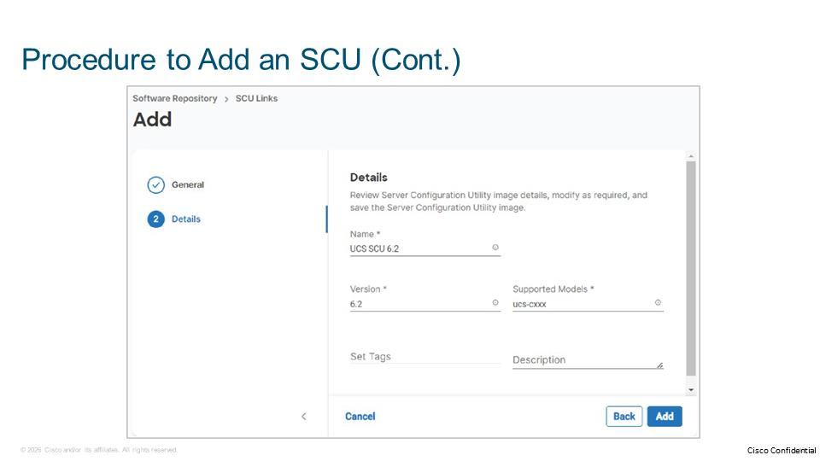
NFS | CIFS | HTTP(S)
File Location: The location of the image file, for example 10.1.17.250/repo/XYZ.iso | File Location: The location of the image file. For example, 10.1.17.250/repo/XYZ.iso | File Location: The location of the image file. For example, https:// 10.1.17.250/repo/XYZ.iso
Mount Options: The choices for mounting as configured in the NFS server. Endpoints use the mount option to mount the remote share as part of a firmware upgrade or operating system install operation. | Mount Options: The choices for mounting as configured in the NFS server. Endpoints use the mount option to mount the remote share as part of a firmware upgrade or operating system install operation. | Username/password: The strings that are the username and password respectively as configured on the HTTP(S) server.
 | Username/password: The strings that are the username and password respectively as configured on the CIFS server.

HTTP protocol is not supported for Cisco IMM servers.

After you add the SCU to the software repository, you can view the added SCU in the table view.
1. Which one of these transfer protocols for adding SCU is not available for IMM servers?
A. NFS
B. CIFS
C. HTTP
D. HTTPS

Operating System Installation Using Cisco Source
This topic describes how to install an operating system using a Cisco-validated template. It also explains how to apply the configuration to the target operating system and lists supported target partitions for the installation process using the Cisco source method.
Procedure for Installing an Operating System Using Cisco Source
Before you initiate operating system installation from Intersight, make sure that you uploaded an SCU and operating system image to the software repository, and that your server Cisco IMC has access to the file paths that are defined in the repository locations.

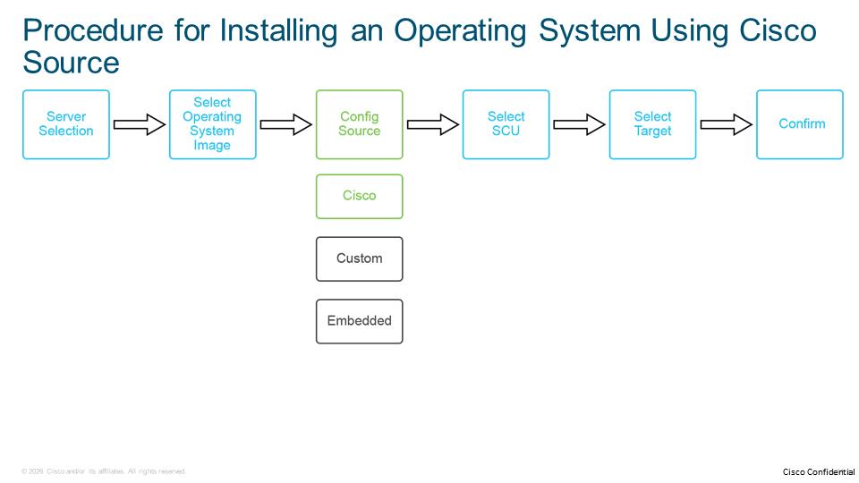
The operating system installation wizard using Cisco source guides you through the following six steps:
- The wizard offers confirmation of the server on which you want to install the operating system. Optionally, you can select two or more servers from the tabled view in Cisco Intersight and perform an automated installation of the operating system to the selected servers.
- Select the operating system and the version that you want to install. The list contains all the operating system images that are defined in the software repository. If you do not see the operating system that you want to install, select Add Operating System Image to add it to the system.
- If you choose the Cisco option, you can use a Cisco-validated template to select the operating system version as the configuration file. Based on the operating system image that you previously chose, Cisco Intersight displays the configuration file in the View File panel.
- Click the eye icon next to the operating system image to view the configuration file on the right. The configuration file contains provisions or placeholders for the necessary configuration parameter values.
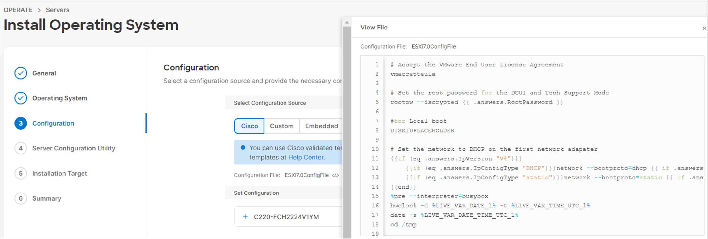
- Cisco Intersight shows the configuration files according to the operating system image version that you select. The Set Configuration section displays the corresponding fields for adding values for the required parameters. Required parameters are mandatory values for a Static IP or DHCP configuration and an option to select the IPv4 protocol or the IPv6 protocol (IP address, netmask or prefix, gateway, name server, hostname, and password). Provide the password for the root/administrator user in the operating system. You can enable the password in encrypted format using the respective encryption mechanism that is supported by the operating system. For Windows installations, you must populate:
- The Product Key field.
- The administrator password.
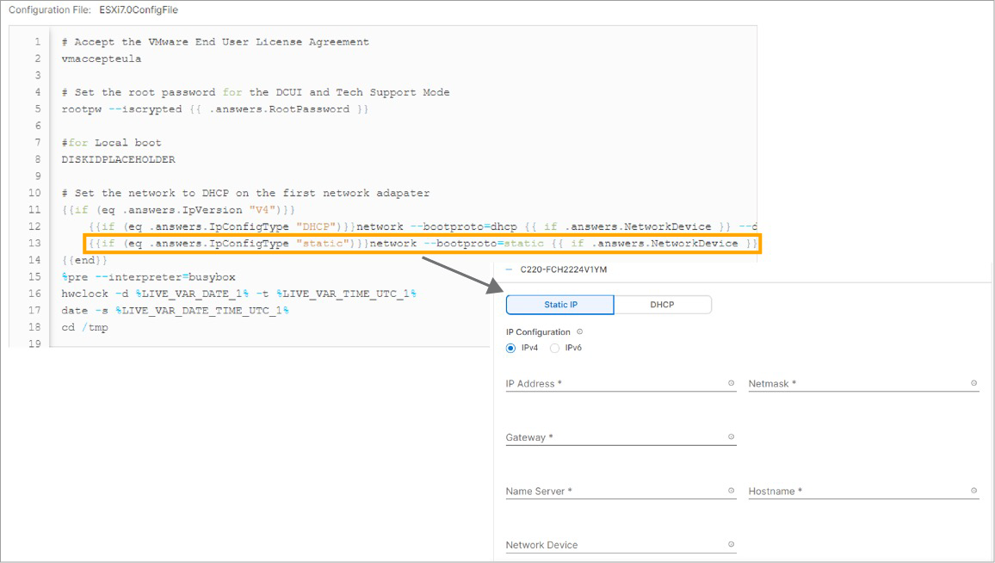
- Select which SCU that you want to apply to during installation. The list within this step contains all SCUs that are defined in the software repository.
Different utilities exist for different servers. For example, you cannot apply an SCU to a Cisco M6 server if it is used for a Cisco M5 server. Always make sure that you have an up-to-date and current SCU.

- Select the installation target. The installation target is the partition where you will install the operating system. The supported targets must meet one of the following conditions:
- The following are supported storage controllers:
- MegaRAID controller
- Cisco Boot Optimized M.2 controller with the server configured in UEFI boot mode
- The following are supported storage types:
- Virtual drives from MegaRAID controllers
- Physical disks configured as Just a Bunch of Disks (JBOD)
- After you have completed the wizard, it provides a summary for you to ensure that all the settings are correct. This step is your opportunity to correct any settings.

You can monitor the installation status under the Active Tasks menu and watch the progress of the operating system install process. You can also monitor the progress using a keyboard, video, mouse (KVM) window to see what is happening in the output from the server. To see the embedded server KVM window inside Cisco Intersight, you must launch tunneled KVM from the server’s Action menu.
1. Which is a supported type of storage controller for installing an operating system from Cisco Intersight?
A. Cisco 12G Modular RAID
B. Cisco Boot Optimized M.2 with server configured in AHCI mode
C. Embedded RAID
D. MegaRAID

Operating System Installation Using Custom Source
This topic describes the procedure of installing an operating system using a custom configuration source. It also explains how to prepare a configuration (kickstart) file and apply it using the install wizard.
Custom Configuration File
You can add new configuration files in the Software > Operating System Configuration Files section. The list of configuration files is filtered based on the operating system vendor and version. If you want to create a new operating system configuration file, click the Create New button.
When you install an operating system using the Custom option, the selected configuration file can be static or contain placeholders that you can change at run time. A best practice is to prepopulate the static file with the relevant configuration settings. You can also create a template file with placeholders instead of actual answers. If you use a file with custom placeholders, click the Set Configuration link on the Configuration page. For example, you might need to set the hostname and IP address values for each server. The uploaded answer file placeholder must conform to Golang template syntax.
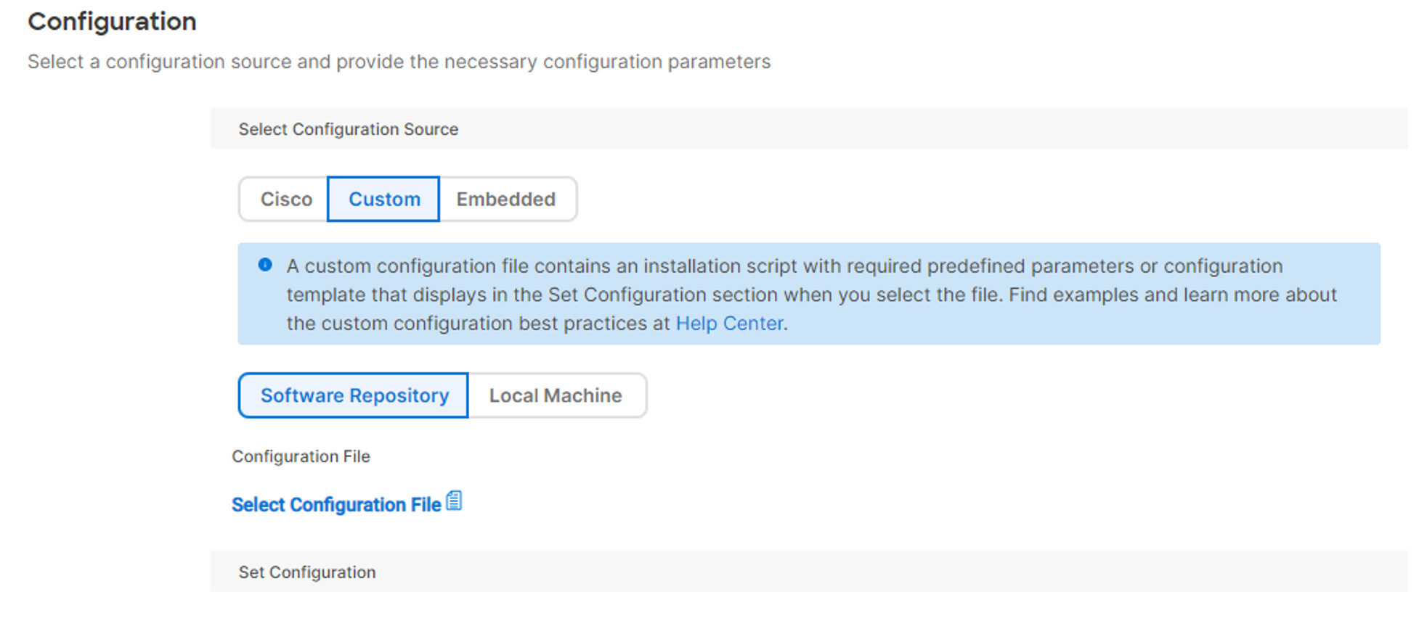
The configuration file contains all the answers that you will provide during the operating system installation procedure. The following is an example of a VMware vSphere ESXi configuration file. Lines that start with the pound sign (#) are comments that explain the next line.
# Sample scripted installation file
# Accept the VMware End User License Agreement
vmaccepteula
# Set the root password for the DCUI and Tech Support Mode
rootpw myp@ssw0rd
# Install on the first local disk available on machine
install --firstdisk --overwritevmfs
# Set the network to DHCP on the first network adapter
network --bootproto=dhcp --device=vmnic0
# A sample post-install script
%post --interpreter=python --ignorefailure=true
import time
stampFile = open('/finished.stamp', mode='w')
stampFile.write( time.asctime() )
You can install an operating system on multiple servers if you define the IP configuration of the host server through the DHCP scope.
When using a custom installation mode, the Cisco Intersight template does not validate the answer file values that you provide. Make sure that you validate the placeholder values when using a custom template. The filename in the custom answer file that you upload must not contain special characters except a period (.), hyphen (-), or underscore (_). Cisco Intersight does not validate the answer file. Validate the answer file using an operating system validation tool, for example, Windows System Image Manager (Windows SIM) for Windows. For non-Windows operating system answer files, confirm that the file does not contain Ctrl+M (carriage return) characters, which can cause unexpected behavior during operating system installation.

Procedure for Installing an Operating System Using Custom Source
The custom operating system installation wizard walks you through six steps. The following figure shows the high-level steps for Custom operating system installation.
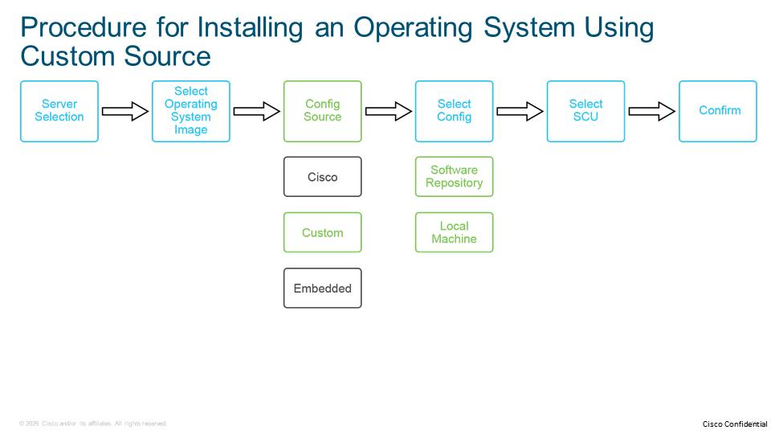
The following steps detail the procedure for Custom operating system installation:
- The wizard offers the confirmation of the server selection on which you want to install the operating system. Optionally, you can select two or more servers from the tabled view in Cisco Intersight and perform an automated installation of the operating system to selected servers.
- You will select which operating system and version that you wish to install. The list contains all the operating system images that are defined in the software repository. If you do not see the operating system that you want to install, select Add Operating System Image to add it to the system.
- With the Custom option, you can upload a kickstart (configuration) file or a file with the necessary placeholders for configuration parameters. The Configuration page of the operating system installation wizard provides two tabs supporting management operating system installation files:
- Software Repository: Select a configuration file defined in the software repository.
- Local Machine: Click Browse and upload the configuration file from your local machine. The file under the Local Machine tab is only available for the current installation.
- The requested values are pulled from the kickstart file that you use. The names that you use in the kickstart file are what you see to populate the variables. Click the eye icon to view the configuration file details.
- Select the installation target, which is the partition in which you will install the operating system. The same type of installation target is supported with both the Cisco and Custom options.
- The wizard provides a summary for you to review, to verify that all the settings are correct. This step is your opportunity to correct the configuration.

You can monitor the installation status under the active tasks menu and watch the progress of the operating system install process. You can also monitor the progress using a keyboard, video, mouse (KVM) window to see what is happening in the output from the server. To see the embedded server KVM window inside the Cisco Intersight, you must launch the tunneled KVM from the server’s Action menu.
After you enter the required values, the installation prompts and warns the administrator that it will start the installation and overwrite any existing operating system that might be there.
1. The configuration file template must comply with which of the following programming languages?
A. Golang
B. Java
C. Python
D. Ruby

Operating System Installation Using Embedded Source
This topic describes the procedure of installing an operating system using the single ISO file that contains all the necessary configuration files for operating system installation.
ISO File for Embedded Installation
An Embedded installation applies the ISO image that you provide and assumes that everything that it needs is already on it. As an administrator, you must create this ISO image to support an automated installation. During installation, you will point to this ISO image, so the image must contain all the necessary configuration files for the target operating system. Optionally, you can select an SCU to use with the ISO image.
Creating an automated ISO image depends on the target operating system and customization level that you want to achieve, but the basic procedure for most operating systems has three steps:
- Extract the original ISO file to a working directory used for modifications.
- Create and modify the kickstart configuration file and add it to an extracted ISO directory. Optionally, modify the boot file to specify the location of the installation script.
- Recreate the ISO image using the content of the working directory using the ISO creation utility, such as mkisofs or genisoimage.

Procedure for Installing an Operating System Using Embedded Source
The Embedded operating system installation wizard walks you through five steps.
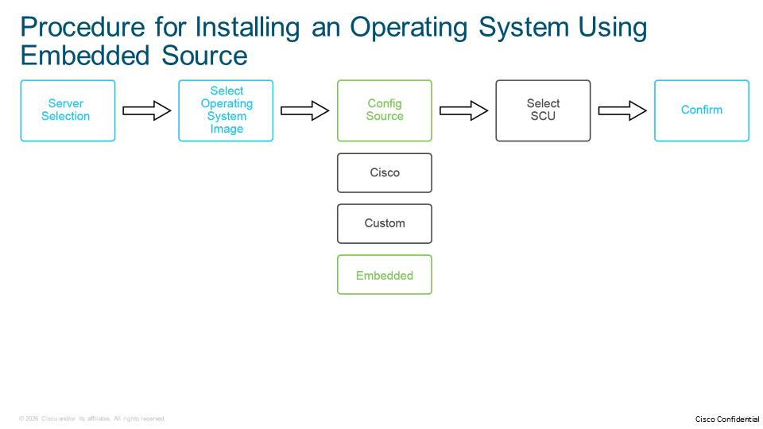
The following steps explain the detailed procedure for an Embedded operating system installation:
- The wizard offers confirmation of the server selection on which you want to install the operating system. Optionally, select two or more servers from the tabled view in Cisco Intersight and perform an automated installation of the operating system to the selected servers.
- Select which operating system and version to install. The list contains all the operating system images that are defined in the software repository. You must add an embedded ISO image location to the software repository before you run an operating system install procedure.
- Select the Embedded option. You will not be able to modify your target operating system configuration. Your configuration should be embedded in the ISO image that you selected in the previous step.
- Optionally, select the SCU to run on this server before the ISO image.
- After you have completed the wizard, it will provide a summary for you to review and validate that all the settings are correct. This step is your opportunity to correct any settings in the configuration.

After you initiate the operating system installation using the Embedded option, the Cisco IMC pulls the ISO image from the sharing location, and the server locally initiates the installation from the provided ISO.
From Cisco Intersight, you can monitor the limited execution flow for the operating system install process. After Cisco Intersight validates the server configuration, the server prepares and downloads the ISO file and sets the boot order. Installation progress is not available in Cisco Intersight, but you can track when the server completes the installation. The following is an example of the post-install tracking for VMware vSphere ESXi:
%post --interpreter=busybox --ignorefailure=true ESXI_INSTALL_LOG=/var/log/esxi_install.log
echo \"OS INSTALL COMPLETED\" >> /var/log/Xinstall.log /opt/ucs_tool_esxi/ucs_ipmitool write_file /var/log/Xinstall.log osProgress.log
1. Which two ISO utilities can be used to create ISO files with embedded configuration files (kickstart files)? (Choose two.)
A. genisofs
B. genisoimage
C. ISO mount
D. mkfs
E. mkisofs

Understanding Placeholder Variables
A placeholder is a variable that you define in the configuration files. During the operating system installation, you assign values to the placeholders. You can use placeholders for Cisco and Custom operating system installations. Two types of placeholders are in the configuration files: custom and internal.
Custom Placeholders
In the operating system installation wizard, Cisco Intersight prompts you to provide a value for the parameter. Cisco Intersight assigns the value to a custom placeholder. Intersight replaces the placeholder with the value.
Use the following examples of custom placeholders in your configuration files:
{{.secure.Password}}
network --bootproto=static --ip={{ .IpAddress }} --netmask={{ .Netmask }} --gateway={{ .Gateway }} --host name={{ .Hostname }} --nameserver={{ .NameServer }}
You can express custom placeholders using conditional expressions in the answer file:
{{if (eq .IpConfigType "dhcp")}}network --bootproto=dhcp {{end}}
{{if (eq .IpConfigType "static")}}network --bootproto=static --ip={{ .IpAddress }} --netmask={{ .Netmask }} --gateway={{ .Gateway }} --host name={{ .Hostname }} --nameserver={{ .NameServer }} {{end}}
Internal Placeholders
When you define your kickstart file, the operating system installation requires mandatory placeholder strings. Cisco Intersight replaces the content of internal placeholder variables with an appropriate value during the installation. You cannot change internal placeholders because the system predefines them. Internal placeholders are expressed in all capital letters in the configuration files.
Depending on the operating system that you are installing, include the following placeholders in the kickstart (answer) file:
- DISKIDPLACEHOLDER (all operating systems)/DISK_NAME_PLACEHOLDER (SUSE Linux Enterprise Server (SLES): Populates the target disk where you want to install your operating system. This placeholder is required for all operating system installations. For example, VMware vSphere ESXi's kickstart (answer) file contains this placeholder.
# Accept the VMware End User License Agreement
vmaccepteula
# Set the root password for the DCUI and Tech Support Mode
rootpw {{ .secure.Password }}
#for Local boot
DISKIDPLACEHOLDER
# Set the network to use a static IP on the first network adapter
network --bootproto=static --ip={{ .IpAddress }} --netmask={{ .NetMask }} --gateway={{ .GateWay }} --host name={{ .HostName }} --nameserver=={{ .NameServer }}
<< Output omitted >>>
- PARTITIONPLACEHOLDER: Populates the partition where you want to install your operating system. You must define the placeholder for Windows operating system installations. For example, the unattended file for Windows 2019 Server contains this placeholder:
<Value>Windows Server 2019 SERVERDATACENTER</Value>
</MetaData>
</InstallFrom>
<InstallTo>
<DiskID>DISKIDPLACEHOLDER</DiskID>
<PartitionID>PARTITIONPLACEHOLDER</PartitionID>
</InstallTo>
<InstallToAvailablePartition>false</InstallToAvailablePartition>
<WillShowUI>OnError</WillShowUI>
<< Output omitted >>>
- OS_INSTALL_COMPLETED_STATUS_PLACEHOLDER: Tracks and notifies the completion of operating system installation. You must include DISKIDPLACEHOLDER with OS_INSTALL_COMPLETED_STATUS_PLACEHOLDER to track installations. The placeholder is required only for RHEL and CentOS installations. For example, the unattended file for RHEL contains this placeholder:
<< Output omitted >>>
%post --nochroot --log=/root/ks-post.log
OS_INSTALL_COMPLETED_STATUS_PLACEHOLDER
%end
reboot

The Go Template placeholder variables should contain only alphanumeric characters.

Do not insert multihierarchy or multilevel placeholders. A multihierarchy placeholder contains nested levels of placeholder values.

For more examples of kickstart files for different operating system versions, refer to https://github.com/CiscoDevNet/intersight-BMaaS/tree/main/os-install/kickstart-samples.
1. Which two types of placeholders exist in the operating system configuration files? (Choose two.)
A. automatic
B. custom
C. external
D. internal
E. static
F. variable

Password Encryption in Operating System Install
You can enter a plaintext or encrypted password in the operating system install wizard. If you enter a plaintext password, Cisco Intersight automatically encrypts it. This topic explains operating system-specific considerations for the encryption of different types of passwords.
Specific Considerations
You can use a password encryption service for both Cisco and Custom operating system installations.
For VMware vSphere ESXi and other Linux-based operating systems, you can generate a secure (hashed) password on another Linux-based system using the SHA-512 algorithm with the mkpasswd --method=sha-512 command. Alternatively, use an online encoding source to generate the password by specifying SHA-512 in the protocol options.
Windows-based systems use the base64 method to generate an encrypted password. Confirm that you set the destination character to UTF-16LE. To get the password, apply a password encrypting service and append the password with AdministratorPassword. For example, if your password is myPassword1234, enter myPassword1234AdministratorPassword. Enable the Password provided is in encrypted format check box to use an encrypted password in the Password field in the operating system installation wizard.
If you use custom templates to install Windows, you must provide two placeholder passwords for the Auto Logon and the Administrator passwords in the following formats in the answer file:
- For Auto Logon passwords, append the suffix Password. The following figure shows the placeholder for the Auto Logon with this suffix.
<AutoLogon>
<Passwords>
<value>{{.PlaceholderAutoLogonPassword}}</Value>
<PlainText>false</PlainText>
</Password>
<Enabled>true</Enabled>
<LogonCount>1</Logoncount>
<username>Administrator</Username>
</Autologon>
- For Administrator passwords, append AdministratorPassword to the password. The following figure shows the placeholder for the Administrator password with this suffix.
<AdministratorPassword>
<value>{{.PlaceholderAdministratorPassword}}</Value>
<PlainText>false</PlainText>
<AdministratorPassword>

When you populate these two placeholders, passwords are generated, and Cisco Intersight passes this configuration file to the operating system.
<AutoLogon>
<Password>
<Value>QwBsAG8AdQBwAGkAYQAhADEAMgAzAFAAYQBzAHMAdwBvAHIAZAA=</Value>
<PlainText>false</PlainText>
</Password>
<Enabled>true</Enabled>
<LogonCount>1</LogonCount>
<Username>Administrator</Username>
</AutoLogon>
<AdministratorPassword>
<Value>QwBsAG8AdQ8wAGkAYQAhADEAMgAzAEEAZABtAGkAbgBpAHMAdAByAGEAdABvAHIAUABhAHMAcw83AG8AcgBkAA==</Value>
<PlainText>false</PlainText>
</AdministratorPassword>
1. Which encoding method is used in Windows-based systems to generate an encrypted password?
A. ASCII
B. base64
C. blob
D. utf-8

Operating System Installation Using a CSV File
You can install an operating system on multiple servers using comma-separated values (CSV). In the CSV file, you will specify the installation parameters of the operating system for each server. The CSV file contains all the necessary settings for operating system installation, such as server serial number, operating system image, IP settings, and passwords. In this topic, you will learn how to use a CSV file in the operating system installation procedure and how to create a CSV file for installation.
Procedure for Installing an Operating System Using a CSV File
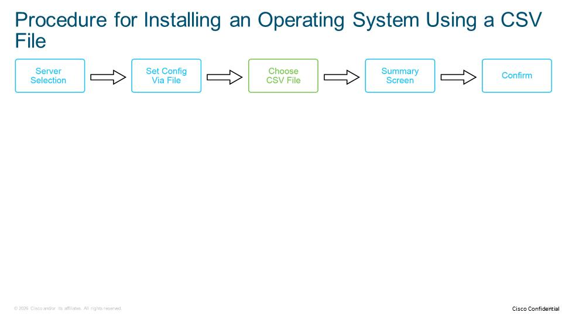
The procedure for installing an operating system using a CSV file is as follows:
- Initiate the operating system installation with CSV by selecting the servers defined in the CSV file, clicking the ellipsis (...) symbol in the top left of the Servers report, and choosing Install Operating System.
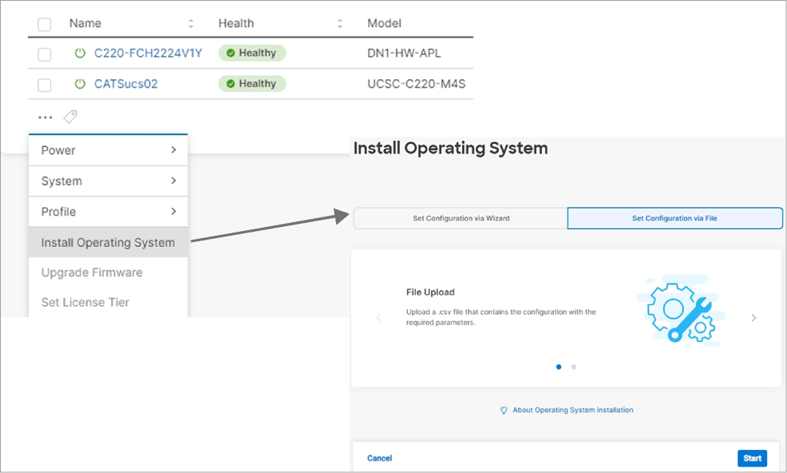
- The operating system install window opens with the Set Configuration via Wizard tab selected.
- Click the Set Configuration through the File tab.
- Click the Start button and the File Upload screen displays.
- Click the Browse button to navigate to the CSV configuration file you want to use for the selected servers. Select your CSV file. Cisco Intersight returns to the File Upload screen, displaying the selected file in the Selected File field.
- Confirm the uploaded CSV file is present. Click Next. Cisco Intersight displays the Summary screen with the selected file in the File Upload field. Review the summary details and confirm they match the fields of the CSV file you uploaded, for example, values in the Serial Number column.
- Click Install to install the operating system. Cisco Intersight displays an intervening message, warning you to make sure you want to install the new version on target servers.

CSV File Format
Using the CSV data format, you can build a textual file containing data records in a tabular format for each server operating system.
You can create a CSV data file using a text editor such as Microsoft Notepad. Use a separate line to enter data for each server. Separate each data field with a comma and include comma separators for blank fields. Enter data on every line in the data file because an error occurs during the insert transaction if you enter a blank line in a CSV file.
Cisco recommends uploading Text-Based CSV files saved in the UTF-8 format only, as characters other than ASCII characters can be stored in this format.

The CSV file must have the appropriate comma-delineated columns. The following are examples of typical column (header) parameters in the CSV file:
- OsImageName: Navigate to Software Repository > Operation Systems Images to obtain the OsImageName parameter value.
- SerialNumber: Serial number of a target server.
- overrideSecureBoot: Specify override secure boot config for secure boot VMware vSphere ESXi installation.
- ScuImageName: Navigate to Software Repository > Software Configuration Utilities to get the ScuImageName parameter value.
- ConfigurationSource: The possible modes of installations are Cisco, Embedded, and Custom.
- IpConfigType: The possible values are Static and DHCP.
- IpAddress: Specify the IP address to be assigned to the server. The IP address can be IPv4 or IPv6.
- NetMask/Prefix: Specify the netmask for IPv4 and the prefix for IPv6.
- Gateway: Specify the gateway address for the server.
- Password: Specify the password for administrator/root.
- ProductKey: Specify the Windows operating system product key.

Some parameters are specific to the installation mode, such as Cisco or Static.

The following example of a CSV file shows two headers. The first header, and values that are assigned to its parameters, are common for each target server. The values that are assigned after the second header are values for each server, one per line of the CSV file.
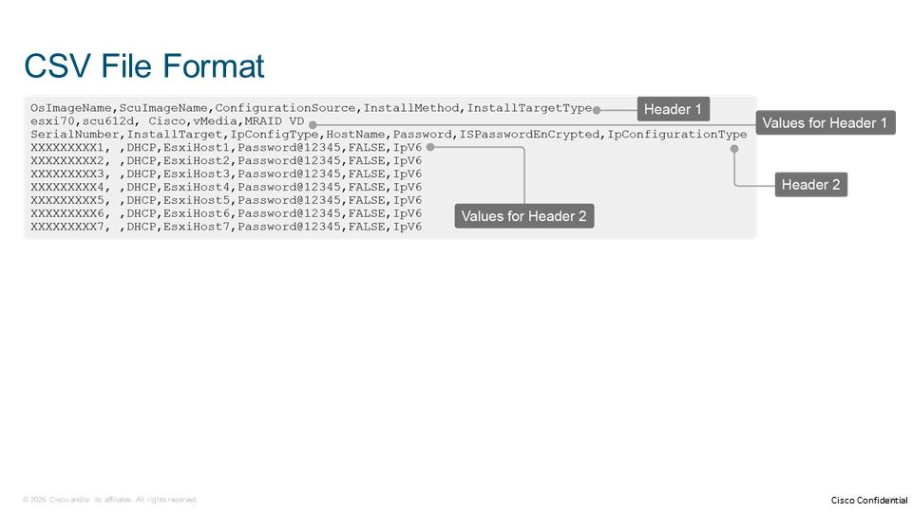
For more examples of kickstart files for different operating system versions, refer to https://github.com/CiscoDevNet/intersight-BMaaS/blob/main/os-install/bulk-install-csv-samples/
1. Which of the following encoding formats is recommended for creating text-based CSV files?
A. ASCII
B. base64
C. blob
D. utf-8

Summary
You are now familiar with the prerequisites for installing the operating system using Cisco Intersight and how to add the necessary files to the software repository used in the operating system installation procedure. This course also covers how to install the operating system using three different configuration sources, use of placeholders in operating system configuration files, and install the operating system on multiple servers using a CSV file.

Summary Challenge
Summary Challenge
Form
Item Group
1. Which of the following operating system installation types are available in the Cisco Intersight? (Choose three.)
A. Cisco
B. Custom
C. Embedded
D. ISO
E. Repository
F. Third-party
2. Which of the following types of servers are supported targets for the operating system installation feature from the Cisco Intersight? (Choose three.)
A. B-Series
B. C-Series
C. HX Series
D. S-Series
E. Third-party
F. X-Series
3. Which of the following transfer protocols are available options for adding operating system images and SCU files in the Cisco Intersight? (Choose three.)
A. CIFS
B. FTP
C. HTTP(S)
D. NFS
E. SCP
F. SFTP
G. TFTP
4. When using the custom source for the operating system installation feature using Cisco Intersight, which of the following options are available for selecting the configuration file? (Choose two.)
A. Embedded
B. GitHub
C. Local Machine
D. Network Share
E. Software Repository
5. Which of the following steps is mandatory in the operating system installation process using embedded source?
A. Populate placeholders
B. Select configuration file
C. Select operating system image
D. Select SCU
6. Which of the following placeholders is mandatory for all types of operating systems?
A. DISKIDPLACEHOLDER
B. DISKPLACEHOLDER
C. PARTITIONIDPLACEHOLDER
D. PARTITIONPLACEHOLDER
7. Which of the following is the correct separator for values of parameters in a CSV file used for the operating system install feature in the Cisco Intersight?
A. Comma
B. Enter
C. Semicolon
D. Space
Objectives Tree
Describe prerequisites and various options for installing an operating system from Cisco Intersight
Describe the operating system installation process using Cisco Intersight
Describe requirements and limitations for the operating system installation process using Cisco Intersight
Describe the procedure of adding an operating system image to software repository in Cisco Intersight
Describe the procedure of adding an SCU image to the software repository in Cisco Intersight
Describe the procedure of installing an operating system with the Cisco option in Cisco Intersight
Describe the procedure of installing an operating system with the Custom option in Cisco Intersight
Describe the procedure of installing an operating system with the Embedded option in Cisco Intersight
Describe the configuration parameters used in the operating system configuration files
Describe password encryption for operating system installation in Cisco Intersight
Describe the operating system installation procedure using the CSV file
Describe how to install an operating system


